**BIG DATA EXERCISE 1**

**Queries**

**Populate the database with atleast 15 database**

**Inserting values**

db.employee.insertOne({Name:{Fname:"varsha",Mname:"h",Lname:"a"},Age:25,Salary:75000,Designation:"Manager",Role:["Tester","UI designer"]})

{

acknowledged: true,

insertedId: ObjectId("62988282d5c4a869459b278b")

}

varshaemployee> db.employee.insertOne([{firstname:"varshitha",middlename:"j",lastname:"k",age:"28",salary:"70000",designation:"designer",role:"UI designer"}])

{

acknowledged: true,

insertedId: ObjectId("629882c0d5c4a869459b278c")

}

varshaemployee> db.employee.insertOne([{firstname:"ashish",middlename:"r",lastname:"k",age:"26",salary:"75000",designation:"assistant",role:"team lead"}])

{

acknowledged: true,

insertedId: ObjectId("629882edd5c4a869459b278d")

}

varshaemployee> db.employee.insertOne([{firstname:"sushmita",middlename:"p",lastname:"a",age:"27",salary:"61000",designation:"scientist",role:"software developer"}])

{

acknowledged: true,

insertedId: ObjectId("6298832dd5c4a869459b278e")

}

varshaemployee> db.employee.insertOne([{firstname:"amrutha",middlename:"d",lastname:"swamy",age:"35",salary:"20000",designation:"assistant",role:"UI Designer"}])

{

acknowledged: true,

insertedId: ObjectId("6298835fd5c4a869459b278f")

}

varshaemployee> db.employee.insertOne([{firstname:"rohini",middlename:"shreyas",lastname:"shetty",age:"35",salary:"59000",designation:"assistant",rolerole:"software developer"}])

{

acknowledged: true,

insertedId: ObjectId("6298838ad5c4a869459b2790")

}

varshaemployee> db.employee.insertOne([{firstname:"soni",middlename:"kumar",lastname:"iyer",age:"35",salary:"45000",designation:"professor",role:"manager"}])

{

acknowledged: true,

insertedId: ObjectId("629883b8d5c4a869459b2791")

}

varshaemployee> db.employee.insertOne([{firstname:"jagadish",middlename:"kumar",lastname:"a",age:"36",salary:"34000",designation:"scientist",role:"team lead"}

... ])

{

acknowledged: true,

insertedId: ObjectId("62988400d5c4a869459b2792")

}

varshaemployee> db.employee.insertOne([{firstname:"rajesh",middlename:"kumar",lastname:"achar",age:"37",salary:"33000",designation:"Scientist",role:"UI designer}])

Uncaught:

SyntaxError: Unterminated string constant. (1:132)

> 1 | db.employee.insertOne([{firstname:"rajesh",middlename:"kumar",lastname:"achar",age:"37",salary:"33000",designation:"Scientist",role:"UI designer}])

| ^

2 |

varshaemployee> db.employee.insertOne([{firstname:"rajesh",middlename:"kumar",lastname:"achar",age:"37",salary:"33000",designation:"Scientist",role:"UI designer"}])

{

acknowledged: true,

insertedId: ObjectId("62988446d5c4a869459b2793")

}

varshaemployee> db.employee.insertOne([{firstname:"varsha",middlename:"h",lastname:"a",age:"25",salary:"75000",designation:"assistant",role:"software developer"}])

{

acknowledged: true,

insertedId: ObjectId("62988488d5c4a869459b2794")

}

varshaemployee> db.employee.insertOne([{firstname:"dhanush",middlename:"kumar",lastname:"gowda",age:"38",salary:"39000",designation:"Scientist",role:"Manager"}])

{

acknowledged: true,

insertedId: ObjectId("629884abd5c4a869459b2795")

}

varshaemployee> db.employee.insertOne([{firstname:"kunal",middlename:"kumar",lastname:"gowda",age:"37",salary:"38000",designation:"Scientist",role:"team lead"}])

{

acknowledged: true,

insertedId: ObjectId("629884dad5c4a869459b2796")

}

varshaemployee> db.employee.insertOne([{firstname:"shiva",middlename:"kumara",lastname:"r",age:"40",salary:"55680",designation:"Scientist",role:"software developer"}])

{

acknowledged: true,

insertedId: ObjectId("62988503d5c4a869459b2797")

}

varshaemployee> db.employee.insertOne([{firstname:"likhi",middlename:"kiran",lastname:"goswami",age:"37",salary:"68000",designation:"Scientist",role:"team lead"}])

{

acknowledged: true,

insertedId: ObjectId("62988535d5c4a869459b2798")

}

varshaemployee> db.employee.insertOne([{firstname:"hita",middlename:"m",lastname:"gowda",age:"39",salary:"20000",designation:"Scientist",role:"UI designer"}])

{

acknowledged: true,

insertedId: ObjectId("6298855dd5c4a869459b2799")

}

varshaemployee> db.employee.insertOne([{firstname:"vrinda",middlename:"lulz",lastname:"rao",age:"25",salary:"30000",designation:"professor",role:"team lead"}])

{

acknowledged: true,

insertedId: ObjectId("62988594d5c4a869459b279a")

}

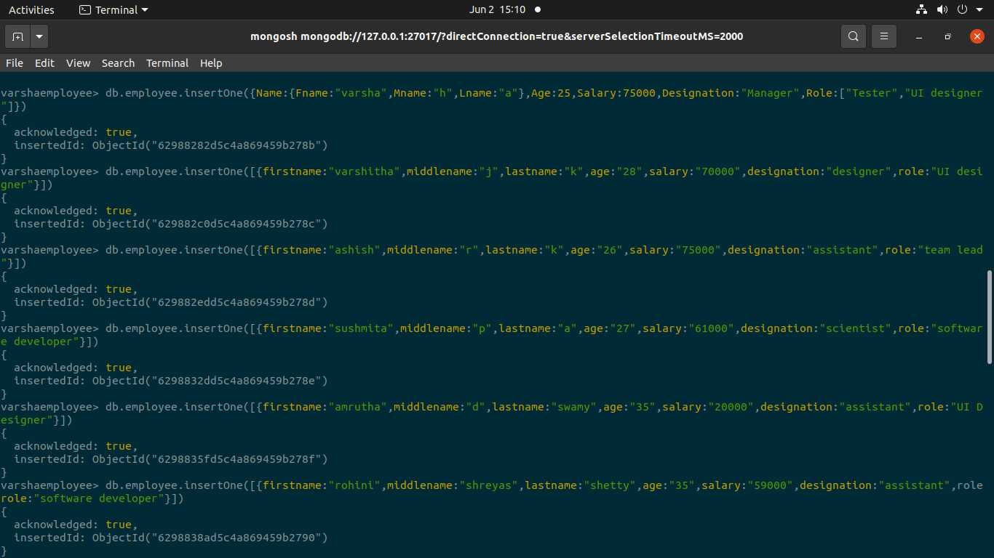

varshaemployee> db.employee.find()

[

{

_id: ObjectId("62988282d5c4a869459b278b"),

Name: { Fname: 'varsha', Mname: 'h', Lname: 'a' },

Age: 25,

Salary: 75000,

Designation: 'Manager',

Role: [ 'Tester', 'UI designer' ]

},

{

'0': {

firstname: 'varshitha',

middlename: 'j',

lastname: 'k',

age: '28',

salary: '70000',

designation: 'designer',

role: 'UI designer'

},

_id: ObjectId("629882c0d5c4a869459b278c")

},

{

'0': {

firstname: 'ashish',

middlename: 'r',

lastname: 'k',

age: '26',

salary: '75000',

designation: 'assistant',

role: 'team lead'

},

_id: ObjectId("629882edd5c4a869459b278d")

},

{

'0': {

firstname: 'sushmita',

middlename: 'p',

lastname: 'a',

age: '27',

salary: '61000',

designation: 'scientist',

role: 'software developer'

},

_id: ObjectId("6298832dd5c4a869459b278e")

},

{

'0': {

firstname: 'amrutha',

middlename: 'd',

lastname: 'swamy',

age: '35',

salary: '20000',

designation: 'assistant',

role: 'UI Designer'

},

_id: ObjectId("6298835fd5c4a869459b278f")

},

{

'0': {

firstname: 'rohini',

middlename: 'shreyas',

lastname: 'shetty',

age: '35',

salary: '59000',

designation: 'assistant',

role: 'software developer'

},

_id: ObjectId("6298838ad5c4a869459b2790")

},

{

'0': {

firstname: 'soni',

middlename: 'kumar',

lastname: 'iyer',

age: '35',

salary: '45000',

designation: 'professor',

role: 'manager'

},

_id: ObjectId("629883b8d5c4a869459b2791")

},

{

'0': {

firstname: 'jagadish',

middlename: 'kumar',

lastname: 'a',

age: '36',

salary: '34000',

designation: 'scientist',

role: 'team lead'

},

_id: ObjectId("62988400d5c4a869459b2792")

},

{

'0': {

firstname: 'rajesh',

middlename: 'kumar',

lastname: 'achar',

age: '37',

salary: '33000',

designation: 'Scientist',

role: 'UI designer'

},

_id: ObjectId("62988446d5c4a869459b2793")

},

{

'0': {

firstname: 'varsha',

middlename: 'h',

lastname: 'a',

age: '25',

salary: '75000',

designation: 'assistant',

role: 'software developer'

},

_id: ObjectId("62988488d5c4a869459b2794")

},

{

'0': {

firstname: 'dhanush',

middlename: 'kumar',

lastname: 'gowda',

age: '38',

salary: '39000',

designation: 'Scientist',

role: 'Manager'

},

_id: ObjectId("629884abd5c4a869459b2795")

},

{

'0': {

firstname: 'kunal',

middlename: 'kumar',

lastname: 'gowda',

age: '37',

salary: '38000',

designation: 'Scientist',

role: 'team lead'

},

_id: ObjectId("629884dad5c4a869459b2796")

},

{

'0': {

firstname: 'shiva',

middlename: 'kumara',

lastname: 'r',

age: '40',

salary: '55680',

designation: 'Scientist',

role: 'software developer'

},

_id: ObjectId("62988503d5c4a869459b2797")

},

{

'0': {

firstname: 'likhi',

middlename: 'kiran',

lastname: 'goswami',

age: '37',

salary: '68000',

designation: 'Scientist',

role: 'team lead'

},

_id: ObjectId("62988535d5c4a869459b2798")

},

{

'0': {

firstname: 'hita',

middlename: 'm',

lastname: 'gowda',

age: '39',

salary: '20000',

designation: 'Scientist',

role: 'UI designer'

},

_id: ObjectId("6298855dd5c4a869459b2799")

},

{

'0': {

firstname: 'vrinda',

middlename: 'lulz',

lastname: 'rao',

age: '25',

salary: '30000',

designation: 'professor',

role: 'team lead'

},

_id: ObjectId("62988594d5c4a869459b279a")

}

]

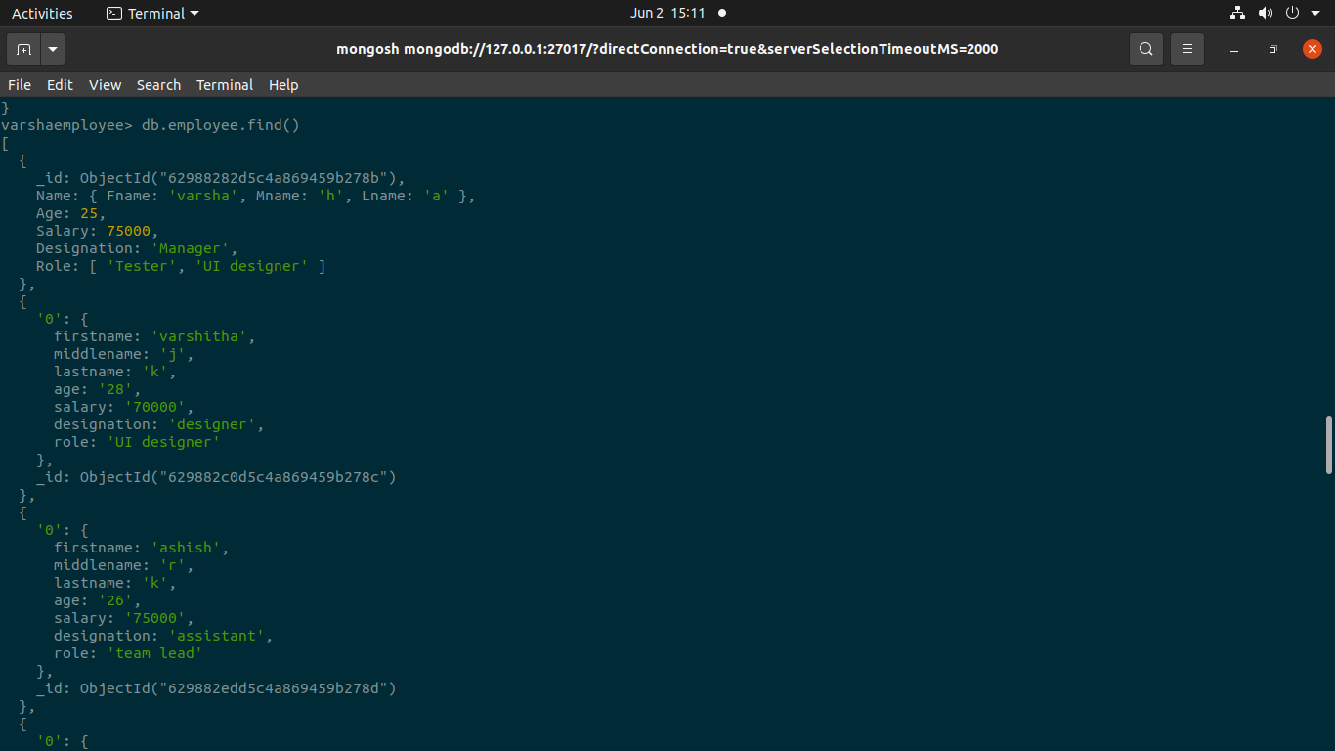

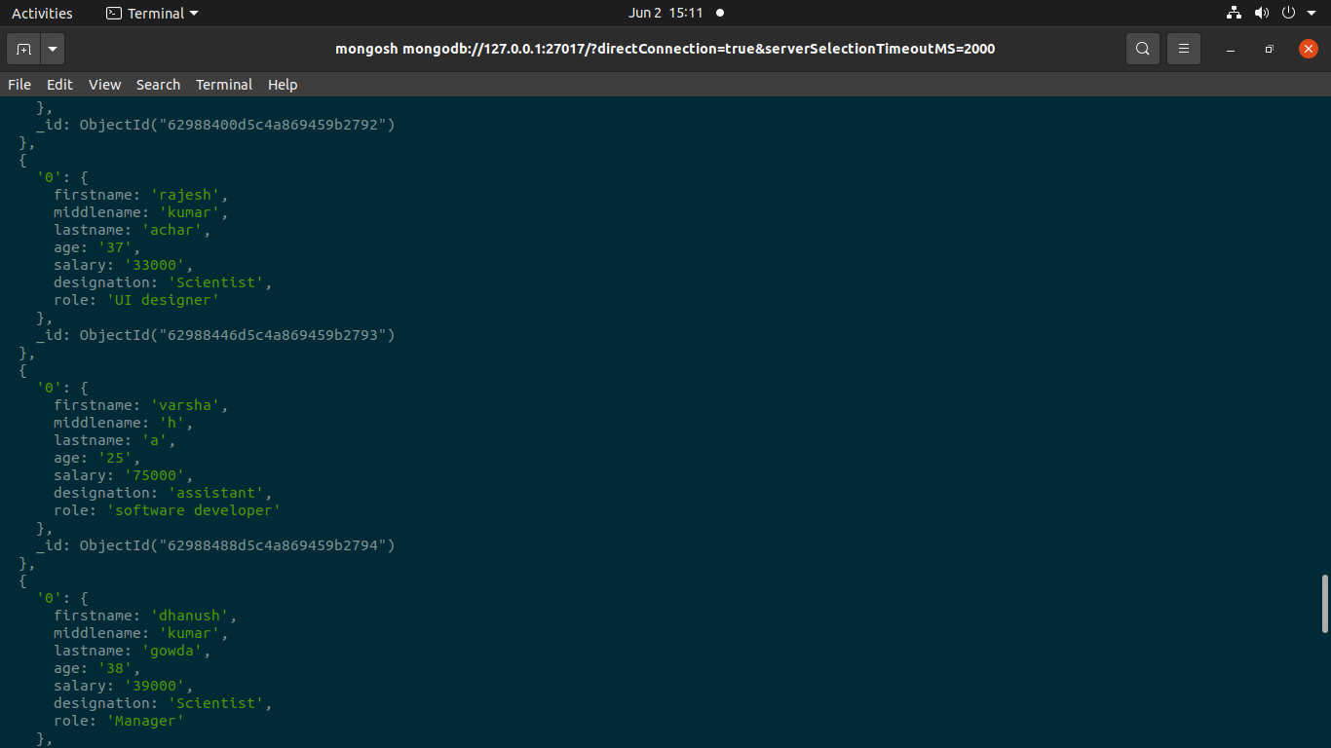

**List all the employees whose middle name is “kumar”**

varshaemployee> db.employee.find({"middlename":"kumara"})

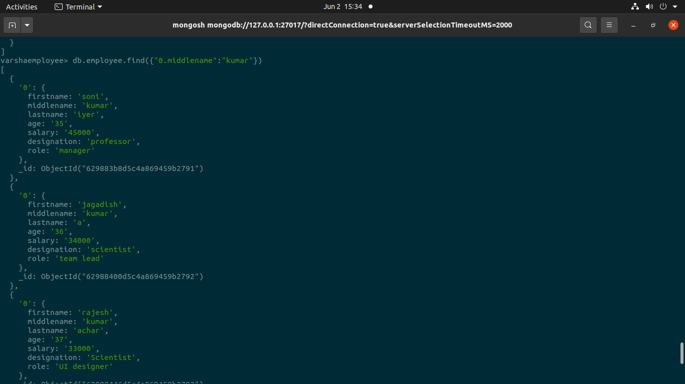

**Count the number of Employees who has a role "Manager" in the Role field**

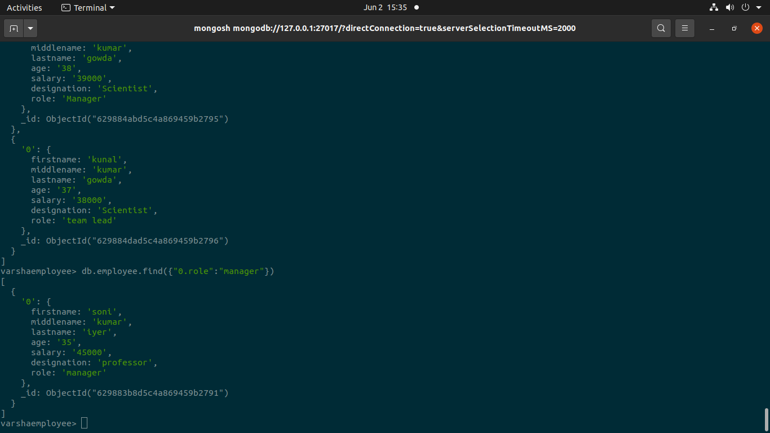

**Delete an Employee whose "Firstname" is "Rajesh" and having the designation as "Scientist"**

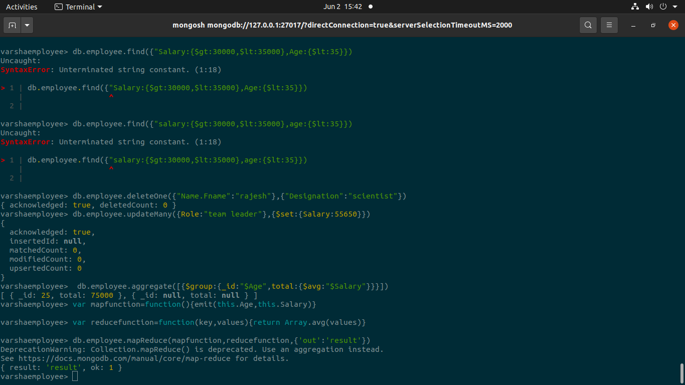

**Update all the Employees whose role is "Team Lead" with a salary of 55650 INR**



**Group all the Employees by their age(common age should be there) and calculate the average salary obtained in the each group**

